HABIT II User Story Analysis

Following Stories are covered in this document.

|  |  |
| --- | --- |
| **Story ID** | **Description** |
| 105 | Patient Status color coding |
| 107 | Patient Demographics and medical history reports |
| 112 | Key data as tables along with graphics |
| 113 | Study Events graphics |
| 104 | Date ranges for patient reports |
| 110 | Symptom graphics |

**Story ID – 105: (**Sharda**)**

As a Nurse using the HABIT-II HealthCOM portal, I need to be able to see color coded summaries of the status of all of patient’s at my hospital in a way that I am not bogged down in too much detail.

**Understanding:**

1. It is specific to a User Role - Nurse who would want a color coded summary of all patient’s health status for a site.
2. Changes to be made in the View Patients summary table, we need to make Status Column as color coded.
3. Integrate with the Alerts module and based on type of alert, show color coding for each patient

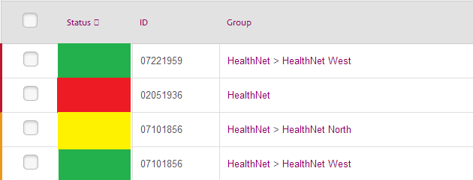

Actual columns in above table will be:

1. Status
2. Subject ID
3. Group
4. Date/Time of last Transaction (local)
5. BNP
6. Weight
7. Answers to 5 Symptom Questions
8. Alerts Summary (Y/N)

**Open Questions:**

1. What color codes should be used? Red / Yellow / Amber are assumed.
2. Assuming that the information required for defining the threshold of each color code will be provided from Alerts module
3. The data presented on this page must be linked to the permissions set for each arm of the study. What is meant by arm of study? How can it be determined?

**Story ID-107: (Vikas)**

As a user of the HABIT-II HealthCOM portal, I need to be able to see demographics and medical history information to be able to put the results of BNP, weight and symptoms data into context.

**1. Understanding:**

A new report needs to be developed that can display demographic and medical Information of single subject or group of subjects. Report will be generated depending upon various filters applied by user. Do we need to export this report to PDF / Doc file?

**2. Access:**

This report should be accessible to all users who can view patient information “on” in their user functions.

**3. Report:**

Report on web page should display following columns in tabular form. This data will be fetched from eCRF system. What should be the sequence of columns?

1. Site ID
2. Subject ID
3. Meter ID
4. Randomization Arm
5. Age
6. Sex
7. Height
8. Weight
9. %LVEF
10. AFIB y/n
11. Blood Pressure(sp/dp)
12. Diabetes (y/n)
13. Angina (y/n)
14. CAD (y/n)
15. COPD (y/n)
16. CRT (y/n)
17. Hyperlipidemia (y/n)
18. Hypertension (y/n)
19. Prior MI (y/n)
20. Alcohol or drug abuse (y/n)
21. Other arrhythmia or tachycardia (y/n)

**4. Filtering:**

Considering having the filter criteria as:

1. Site ID (All or specific), Subject ID (All or specific), Randomization Arm, Sex
2. Age Range, Weight Range, Height Range

**Story ID-112: (Vinoth)**

As a user of the HABIT-II HealthCOM portal, I need to be able to see some key data as tables in addition to graphics.

**1. Understanding:**

We need to develop / modify existing views to show tabular data along with the Graphical representation of those data. The following data tables need to be shown:

1. BNP Data Table
2. Weight Data Table
3. Study Events Table
4. Medications Table
5. Lab Tests: Creatinine
6. Lab Tests: Potassium
7. Lab Tests: BNP

**2. Access:**

This Tabular format Data should be accessible to all users who can view “Patient” information, as defined in User Functions / profile

**3. Data Table Formats:**

|  |  |  |  |
| --- | --- | --- | --- |
| **BNP** | | | |
| **Date/time (local)** | **Date/time (GMT)** | **BNP Value (pg/mL)** | **Alert #** |

|  |  |  |  |
| --- | --- | --- | --- |
| **Weight** | | | |
| **Date/time (local)** | **Date/time (GMT)** | **Weight (kg/lbs)** | **Alert #** |
|  |  |  |  |

|  |  |  |  |  |  |
| --- | --- | --- | --- | --- | --- |
| **Study Events** | | | | | |
| **Date/time (local)** | **Date/time (GMT)** | **Clinical Decompensation** | **HF Hosp**  **Admit** | **HF Hosp Discharge** | **HF Death** |
|  |  |  |  |  |  |

|  |  |  |  |  |  |  |  |  |  |
| --- | --- | --- | --- | --- | --- | --- | --- | --- | --- |
| **Medications** | | | | | | | | | |
| **Drug Name** | **Drug Class** | **Start Date** | **Stop Date** | **Dose** | **Units** | **Frequency** | **Route** | **Reason for change** | **Change based on** |
|  |  |  |  |  |  |  |  |  |  |

|  |  |  |  |
| --- | --- | --- | --- |
| **Lab Tests: Creatinine / Potassium / BNP** | | | |
| **Date/time (local)** | **Date/time (GMT)** | **Value** | **Units** |

**4. Data Source:** All data will be retrieved from HealthCom2 HeartCheck DB.

**Story ID-113:** (Hiten)

As a user of the HABIT-II HealthCOM portal, I need to be able to see a graphic representation of study events. An alternative approach is to graph study endpoints (HF-Death, HF-Hospitalization, and clinical decomposition) as separate graphics distinct from the BNP graphics.

1. Understanding:

A new graphic chart needs to be developed that can plot Study Related events for better visualization of data.

2. Access:

This chart should be accessible to all users who can view “Patient” information, as defined in User Functions / profile

3. Study End Points to be plotted are the below 4, are there any more events to be considered?

1) Clinical decomposition

2) HF-Hospitalization Admit

3) HF-Hospitalization Discharge

4) HF-Death

4. Data for Study Events:

Assuming we will have the following data available to plot the various events on a time axis (i.e. Date/time, Type of Event, Patient info )

|  |  |  |  |  |  |
| --- | --- | --- | --- | --- | --- |
| **Study Events** | | | | | |
| **Date/time (local)** | **Clinical Decompensation** | **HF Hosp**  **Admit** | **HF Hosp Discharge** | **HF Death** | **Patient ID** |
| 15-Nov-12 | X |  |  |  | 1012 |
| 28-Dec-12 |  |  | X |  | 1541 |
| 20-Feb-13 |  |  | X |  | 2512 |
| 20-Mar-13 |  | X |  |  | 3365 |
| 20-Apr-13 |  |  |  | X | 2210 |

Also the data will need to be fetched from eCRF system. That part of the code would also need to be developed.

5. Chart Visualization:

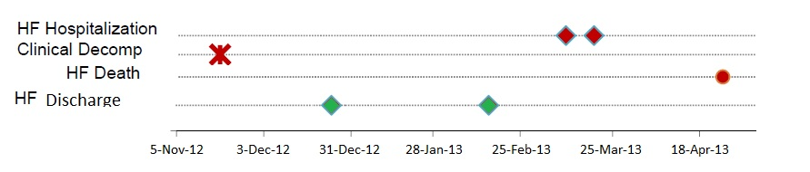

6. Filtering:

What should be the filtering / drill down criteria? Should it be same as for the BNP chart?

**Story ID-104: (Biswa)**

As a user of the HABIT-II HealthCOM portal, I need to be able to conveniently set date ranges for the patient reports so that I am not bogged down in too much detail. § The default ranges should include: 3, 7, 14, 30, 60, 90, 120, 180 days and also include a Start-Stop date entry field.

**1. Understanding:**

We need to develop user control for HABIT-II HealthCOM portal users so that the user can view the patient report based on the defined date range. The default value for the date range to be displayed should be 30 days. Other values in the default range should be 3, 7, 14, 30, 60, 90, 120, 180 days. If user sets a different range (e.g. 60 days) the report page should display the patient report available for 60 days.

Also an additional user control to be developed which will allow the user to set a date range based on a Start Date and End Date. If user set the Start Date and End Date, the report should be displayed based on the specified dates between the Start Date and the End Date.

**2. Access:**

The date range control should be accessible to all users who can view “Patient” report, as defined in User Functions / profile.

**3. User Control**

**Set Date Range**

Control Type: Dropdown List

Values: 3, 7, 14, 30, 60, 90, 120, 180

Default Value: 30

**Start Date / End Date:**

Control Type: Input Box / Date Picker

Values: Date (MM/DD/YYYY)

Default Value: NULL

**Set Date Button:**

**4. Data Source:** All data will be retrieved from HealthCom2 HeartCheck DB.

**Story ID-110: (Biswa)**

As a user of the HABIT-II HealthCOM portal, I need to be able to see symptoms graphed in a convenient and easy to understand way. Daily symptoms measures should be plotted and symbols (circles?) should be color coded. No = green, Red = yes· Symptom Alerts generated from the data are plotted and some way to distinguish which alert.

**1. Understanding:**

We need to develop a new graph that can display the Symptoms related data in an easy and better way for visualization.

For all the symptoms there should be graphical symbols (Circles) displayed for a particular day. If a symptom is positive, the circle to be displayed with circle with Red Color and if a symptom is negative then the circle should be displayed as Green Color.

[Alt discussion: We need to show markers / circle only when symptom occurs for given date]

On mouse hover event, the graph should display more information for that particular symptom.

**2. Access:**

Symptoms report should be accessible to all users who can view “Patient” information, as defined in User Functions / profile.

**3. Chart Visualization**

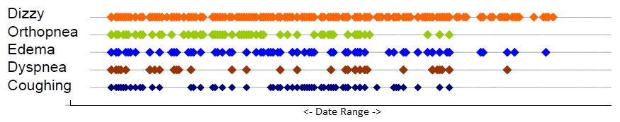

**4. Data Source:** All data will be retrieved from HealthCom2 HeartCheck DB.